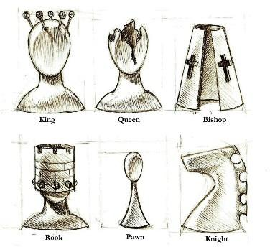

SPA Chess Club

Mission Statement: The St. Paul the Apostle School Chess Club is dedicated to teaching chess to students who are interested in learning the game and potentially competing in chess tournaments. Secondarily, chess instruction increases aptitude in math, science, critical thinking, and analytic skills.

History: The Chess Club is the oldest organized after school activity at St. Paul the Apostle School. Students have won numerous chess awards and tournaments nationwide.

Instructor: We are blessed to have Ivona Jezierska as our instructor. Ms. Ivona became a professional chess competitor at age 14 and is a Women’s FIDE
Master. You may know her as the Critical Thinking teacher at St. Paul the Apostle.

Levels: We have 3 levels of instruction: Beginners/Novices, Intermediate and Advanced. All three levels of ability provide a fun learning environment so that children progress and are in a competitive environment without being overwhelmed. Upon registration your child will be placed in the level that best matches her/his ability or experience.

Schedule: Chess Club meets on Mondays after dismissal, starting on November 22, 2021 and goes from 3:15 until 4:00/4:30.

Beginners (Kindergarten or Novices):

3:05 - 3:15 transition/snack time
3:15 - 3:40 instruction with Ms.Ivona 3:40 - 4:00 free chess play
4:00 – 4:05 pick up from DK Room

Intermediate (1st ~ 3rd Grade):

3:05 - 3:15 transition/snack time
3:15 - 3:40 play chess
3:40 - 4:05 instruction with Ms.Ivona
4:05 - 4:20 free chess play, pick-up from KA

Advanced (3rd Grade and up or by discretion of the chess instructor):

3:05 - 3:15 transition/snack time
3:15 - 4:05 free chess play
4:05 - 4:30 instruction with Ms. Ivona
4:30 - 4:35 pick-up from KA patio

Calendar for 2021-22:

Fall/Winter, 1st Session: Nov 22 to Feb 28: ~10 days (11/22,11/29, 12/6, 12,13, 1/10, 1/24, 1/31, 2/7, 2/14, 2/28) Note: there will NOT be chess Jan 3rd even though there is school that Monday.

Spring, 2nd Session: March 7 to May 23: ~10 days (3/7, 3/14, 3/21, 3/28, 4/4, 4/18, 4/25, 5/2, 5/9, 5/16)

End of the Year Awards Party: May 23 (subject to change in case make-up classes are needed)

Tournaments: We will offer two tournaments this year. A “Back to Chess” SPA tournament on January 10 (after school) and a Spring Tournament in April or May with other schools (on a weekend).

The Chess Club Mini Library: Chess Club members will be able to check out and borrow books about chess strategies and books to help them get tournament- ready. Please email Erin Cook if you would like to check these out.

Tuition: $150 per sesssion. There will be two sessions for this academic year

Expectations and Rules for Chess Students:

- Students must observe the same behavior code that applies to school classrooms. Students must maintain “tournament quiet”: whisper necessary words such as “check;” raise a hand if you have a question. Students breaking these rules will first be requested to comply; if they persist, they will be sent to SPA After-School Care and charged the drop-in rate and the parent will be notified; ultimately for repeated noncompliance the student may be asked to leave the club.
- Respect the instructors, the Teacher’s Assistant(s) and parents. They are in charge.
- No cell phones outside backpacks.
- No food or drink in the classrooms.
- Keep the room clean and straighten up at the end.
- While in Chess Club, activities are limited to listening to instruction, playing chess, doing chess puzzles or reading chess books. Students wishing to play other games or do homework will be sent to After School Care and charged drop in rates

TO REGISTER: https://www.prestoregister.com/cgi-bin/order.pl?ref=spapostle_school&fm=2

Parent Volunteers: If you would like to volunteer to help out at any of our sessions, please do! Knowledge of chess is not required. As with all other volunteering at St. Paul's, you must have a TB test, proof of covid vaccine or plan to test within 72 hours of each volunteer duty day, as well as VIRTUS training and fingerprinting on file with Mayora Hiney.

ANY QUESTIONS, PLEASE E-MAIL: Erin Cook, Director: eatkinson@gmail.com

