SPA chess club
Chess is not always about winning. Sometimes it’s simply about learning. And so is life. |  | Chess Club Mondays are back!  - Registration is now open for the 2021-2022 school year for session 1 (Nov 22, 2021 to February 28, 2022). Session 2 starts March 7.  - All levels of chess, from novice to advanced, are welcome. Grades K - 8.  - Tuition is $150 per trimester  - Parents, please note that the fee is higher than in the past. We have hired some additional staff to oversee the Chess students so we can rely less on parent volunteers.  - Stay tuned for more information on chess tournaments (here at SPA)

Mondays
Beginner Students (DK Room): 3:15-4pm
Intermediate Students (KA): 3:15-4:15
Advanced Students (KA Patio): 3:15-4:30

Our first session is November 22, 2021.

To register, go to: SPA Chess Club Registration
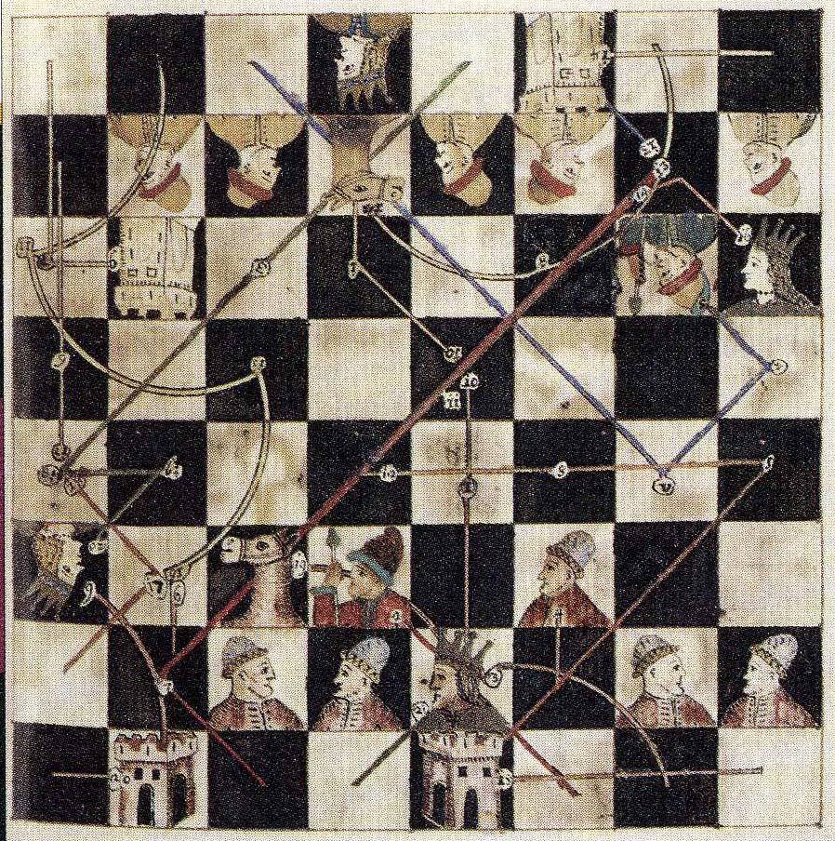
Please direct questions to:
Erin Cook
director, Spa chess club
eatkinson@gmail.com

Due to COVID precautions and staffing needs, the chess club will have a cap on the number of students it can accommodate this year. Sign up early to ensure a spot. We will have a waitlist. We ask for everyone’s patience and flexibility as COVID precautions may lead to unexpected cancellations and limit the space available to play chess!

